Kickass Offline Profits



Imran Naseem
http://www.ImranNaseem.com

Let’s get right into with this report. Everyone knows that there is a TON of money to be made in the offline niche. I am also going to assume that is why you purchased this report.
The only way to get offline clients and get them paying you a ton of money up front and a monthly fee is to have them know that you exist!
If they don’t know who you are and don’t know that you even exist AND don’t know that you can help their business there is absolutely 0 chance that they will ever cut you a check. Can we agree on that much?
There are a ton of ways to get in front of business owners. I am sure that you have read all sorts of reports about them:
- Cold calling. Who really wants to do that?
- Emailing. Can-Spam compliant ways to do this are few and far between.
- Networking. This can be a great way to get in front of the business owners in your local area. It requires you to go out and actually talk to people.
- Asking family and friends. This isn’t some sort of MLM we are starting here!
I am sure that you can add a few more to that list if you have bought a good amount of courses on online marketing. This report isn’t going to debate the merits of any of these methods. They all work if you are willing to put the time and effort into them.
The last method I forgot to mention is buying domains, getting them ranked and then calling business owners. This requires both cold calling and purchasing domains that might sit in your account forever with nothing ever coming of them.
The reason I listed the last method is that we are going to be doing a version of that which won’t cost you the price of a domain name every time you want to target a different niche.
You can target city dentist, lawyer and accountant without having to buy a domain name for each one.
We are going to be leveraging videos and Youtube to get in front of our prospective clients and we are going to force them to notice us!
The twist I put on making sure that THEY NOTICE YOUR VIDEO is 1 of the most clever marketing tactics that I have ever come up with. It is so damn cheap I can’t believe it.
1st thing 1st is that we need something that will cause business owners to pick up the phone and call you. For that to happen you will need some sort of web property.
The video that we are going to be uploading to YouTube will be a quick 1-2 minute video that will sell your services to the prospective business owner. Don’t worry, I will be providing you the script and Power Point template for you to use.
The thing to remember here is that Youtube can’t read the content of the videos. (at least I don’t think they can just yet) That means that the only thing that they have to go on is the description and everything that you put on it when you upload the video.
That means that you can rank these videos for money keywords that the business owners would want their website ranking for. Since the video will be an advertisement for your business you will be proving to them that you can get the job done as far as getting traffic and at the same time be right in their face with your message. I will cover how to make sure that they notice your video later on in the report.
Uploading to YouTube
This is the only part of the process that you have any control over the “On page SEO” since Youtube will only allow you to have certain specs on your video.
The 1st thing that you need to do is makes sure that your video is named the exact term that you are going after. For this example I am going to be using “Houston Dentist”.
The exact title of the video I am going to be talking about would be:
Houston Dentist | Houston Tx Dentist | Dentis Houston Tx
Next thing that we need to focus on is the Description. In the description the 1st thing that you want to add is your offline consulting website. If you don’t have a website you will want to add an email to the description. The video that we are going to be adding to youtube will have the call to action at the end of it.
If you don’t have a website set up for you consulting practice don’t worry because it isn’t necessary. I do suggest that once you have made a sale or 2 that you invest in at least a 3-5 page static site so that you have a place to send potential clients to show them your portfolio and other things. But to get started it isn’t necessary.
Here is an example of what the description will look like:
http://yoursite.com Houston Dentist is the #1 source for Houston Tx dentists. If you are looking for a Dentist in Houston Tx then look no further then this video. Make your next trip to a Houston Tx Dentist a great experience.
Next are the tags. Since we can only use 1 word at a time and not a phrase we will want to make sure that we get all our keywords into the tag box. For this example it will look like this:
Houston dentist tx 77001 dentists
77001 is the zip code for Houston, TX. I like to add that since it will help the video pop up for those who search for something like Dentist 77001.
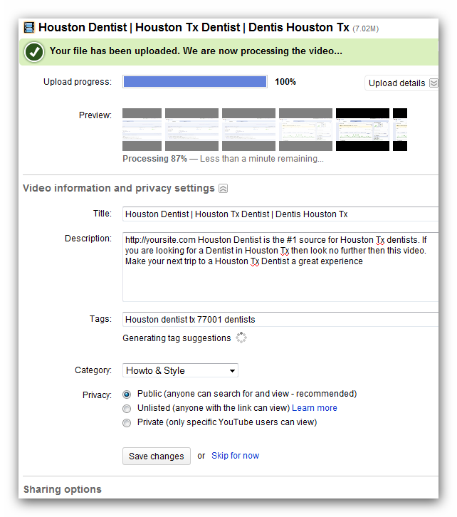
At the bottom and click Save Changes and your video will be uploaded. Now it is time to go in and do the major on page SEO for this video.
Once the video is uploaded you will want to go to your video menu and click on the video that you just uploaded. Once you do that you will need to add the “Date and Map” stamp to the video:
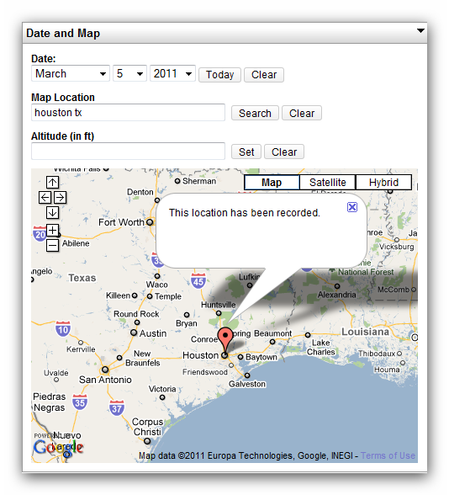
Next thing that we want to do is add Annotations to the video. This will help with on page SEO. Now we will want to add a few of these since we want the on page SEO to be amazing and at the same time have them take action once they see the video.
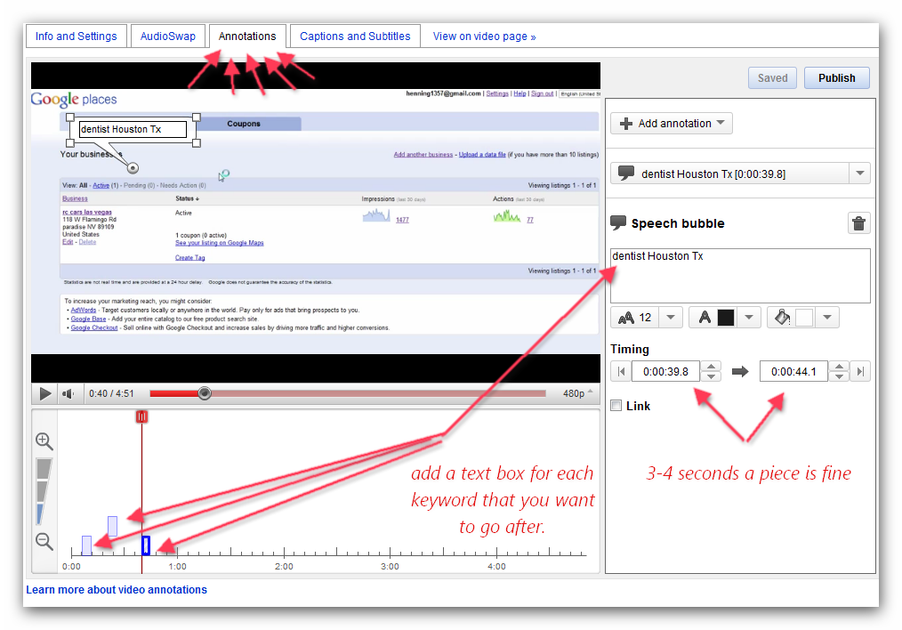
The last thing that you want to do with the video is add an annotation at the end of the video with either you website address and a call to action or your phone number at that point:
“If you would like to see your video here contact me at www.mysite.com or 555-555-5555”

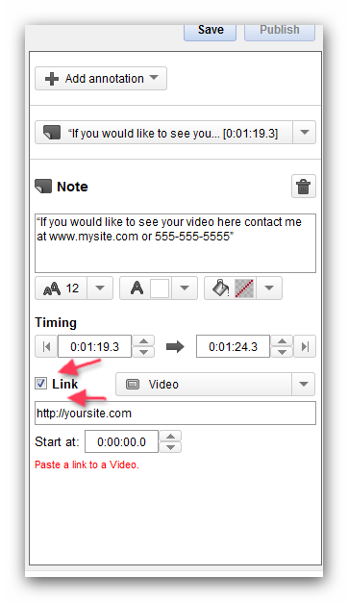

This isn’t something that I have experimented with before but I want to make you aware that the option is here. ON the right hand side of the tabs on the top is a section called “Captions and Subtitles”. I am wondering if you upload a file with keywords that you are targeting to this section that it will help with the on page SEO?
Again, this isn’t something that I have experimented with but I am just putting it out there. If you do mess around with this I would love to hear about your results.
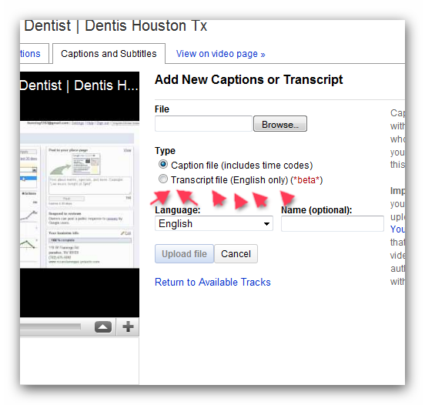
That is it for on page SEO when it comes to Youtube. You want your video to have the proper Title, Description and meta tags.
Then you want to make sure that your video is Geo Targeted towards the location that you are trying to rank for.
The last thing that you want to do is to make sure that you have added annotations that have the keywords that you are targeting as well as a clickable “Call to Action” annotation at the end of the video.
This information can be applied to all different types of Youtube videos and not just these offline videos. Consider this a little “YouTube SEO Course”.

YouTube Off Page SEO:
Now here is where the magic comes in. Since the video has been uploaded to YouTube and we have all the on page SEO done for the video we can get as crazy as we want when it comes to linking to the video.
Normal SEO practices (which I don’t really believe in) say that when you upload a new site that you need to back link to the site/page very slowly. A few links to get started and get the page indexed. Then a few more links and increase the links as you go along.
This logic doesn’t hold true when it comes to YouTube. YouTube gets MILLIONS of links to the site every single day. You can’t blast enough links at your video to really cause it any harm.
With that being said you don’t need to run out and buy 1,000,000 backlinks to the video either. We are dealing with local SEO and the amount of links that we need to get will vary from city to city. A big city will require more links than some small town.
Here it depends on what your level of SEO is. Do you have SeNuke, Magic Submitter, UAW, SEOLinkvine, Article Robot, XRumer, etc.?
The amount of backlinks it takes to get your video #1 will depend on the city and niche that you are targeting. I can’t be any more clear about that. There is no single answer that I can give you that will tell you exactly how many links you will need.
You need to do the SEO until that video is ranking #1 for your city niche. In this example, SEO would continue until the video reaches #1 for “Houston Dentist/s”.
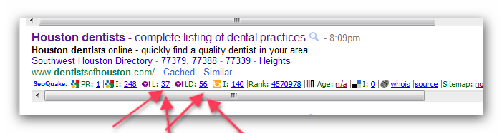
As you can see from the video above, the #1 result when you search for Houston Dentist has a grand total of 37 links pointing to it.
That is why I suggest you start out with a reasonable number of links at first. That way you don’t waste money sending thousands of links to the video when a hundred will do.
Don’t stop once the video reaches the 1st page or the video is in the top 3. You want to be #1 and that is the only thing that matters! Go all out or don’t go at all.
There are courses that cost $997 and up and all they do is talk about SEO. For me to get into it here would be a waste of time. If you don’t have any clue on how to build links to your site I would suggest you OUTSOURCE this task.
Head on over to http://backlinksforum.com/backlinks-classified-ads/
This is the single biggest list of SEO resources that you can ever find. Let me show you a few links to thread that I have tried an got great results from:
http://backlinksforum.com/backlinks-classified-ads/4632-profile-link-pyramid-tier-1-pr4-tier-2-verified-profile-links-just-%2414.html
http://backlinksforum.com/backlinks-classified-ads/5276-affordable-xrumer-pyramid-service-3000-verified-backlinks-double-layer-pyramid.html
http://backlinksforum.com/backlinks-classified-ads/4414-edu-gov-mil-profiles-linkwheel-boost-your-site-affordable-price.html
http://backlinksforum.com/backlinks-classified-ads/5487-scrapebox-blasts-blog-commenting-service-starting-low-%241-per-1k-backlinks.html
http://backlinksforum.com/backlinks-classified-ads/4521-high-pr4-bulk-profile-links.html
What I am telling you is that if you already have the tools in your arsenal to do the SEO work yourself then all you need to do is get on it.
If you don’t have the automated tools I would suggest that you spend a few $$ per video and have someone who is a professional in SEO take care of the heavy lifting.
You can take care of the SEO on your own without using any of the automated tools on the market but I would suggest that if you can afford to pay someone else to do it then go that route.
The sooner you get your first client the sooner you can reinvest your profits back into getting more and more clients! Either be fast and spend a few $$ or you can take your time and let the money trickle in. The choice is up to you.

Getting Clients and Getting Paid:
Now here is where it gets really exciting. I know you probably think that it is going to take a long time for some business owner to notice your video and actually pick up the phone and call you.
Don’t worry about that because I have you covered here. This method is so simple and so CHEAP that I can’t even believe that I am telling it in this report.
Ok, so here is what we are going to do. Cold calling is the best way to get business owners to respond to your amazing 1st page results on the video that is advertising your services.
I know that you don’t want to do the cold calling so here is what and how we are going to do it.
http://www.fiverr.com/users/msallen/gigs/do-cold-calls-for-your-businesses-an-hour
http://www.fiverr.com/users/ghentbelle/gigs/be-your-virtual-assistant--2
http://www.fiverr.com/users/embree/gigs/telemarket-your-products-and-services
There are more on Fiverr.com but I wanted to list just a few.
We are not going to have these people call the businesses that we want to take a look at our video and try to sell them on the idea of becoming a client.
The way we are going to go about this is that these people are going to call the businesses that we want to see our video and ask them what their website address is.
I will go through the whole script below that I give to people who make calls for me. The 1st thing that you need to do is grab the name and # of 5-20 businesses in the city and the niche that you are focusing on.
I would suggest you find those who aren’t coming up on the 1st page of Google or Google Places or Google Maps. These are the companies that need your help the most and that is why we want our new Telemarketers to contact them.
Here is the script so you can see it in action:
-------------------Beginning Script-----------------------
Telemarketer: I was searching for (niche) in (city) and I couldn’t find your website. Whats the url I can find more information about your company.
GateKeeper: Our website is located at xxxxxxxxx.com
Telemarketer: Let me repeat that back to you real quick because I was searching on Google for (niche) in (city) and the 1st thing that kept popping up was some marketing video. I have the URL as xxxxxxxxxxx.com Is that right?
GateKeeper: That is correct. Anything else I can do for you.
Telemarketer: That’s all. I was looking for your site on Google and couldn’t find it. Thanks, I will check out your site and see what you have to offer.
-----------------End Script-----------------------
I want you to take a minute and reread the script that I have just put up above here.
Imaging that you work for a Dentist in Houston and you got a phone call just like that. What would be the first thing that you would do?
I don’t know about you but the first thing I would do is pull up Google and do a search for “Houston Dentist/s” to see what they were talking about. Even if I wasn’t searching for the marketing video they were talking about I would run the search to see who exactly does show up for that search term 1st.
Once they do that they will see that the #1 result is your video that is selling your services to the company!
Do you see how this is coming together?
I hope so because this is some powerful information that I am putting together here.
The key to this whole method is that your Telemarketer never calls the same company more than once. If you do that then they might start to get a little suspicious.
The whole conversation above can be had in less than 2 minutes flat. That means that if someone is willing to make phone calls for 1 hour for you, they will easily be able to make 20 calls.
20 of these phone calls will get your phone ringing in no time. The gatekeepers are there to make their bosses life easier. Do you think if they found the video that you just put up and they let their boss know about it that they would be doing them a favor? Not to mention the fact that they have received a phone call from a potential client that has also seen the video and couldn’t find their website!
It is up to you at this point to close the sale. Just because they called you doesn’t mean that they are going to just hand over a check.
You will still need to sell them on the idea of hiring you for their SEO and online marketing needs.
1 of the 1st things that you can sell them on to get them on board as a paying client is a marketing video for their site. This works great for 2 reasons:
- Videos have high perceived value
- You can easily swap out your video for the newly created video that you do for them.
http://studio.stupeflix.com/
For $59 a month or a yearly fee of $499 you can create as many high quality videos that you want to create. This simply requires you grabbing some images and adding some text that relates to the company that you are selling the video to.
That is the easiest way to get them on as a paying client right away.
The call to action at the end of the video will help them make that purchasing decision a whole lot easier!
There you have it!
Work With Me!
Remember when I said I was going to help 1 person out with getting their first client?
Here is what you have to do to qualify.
Leave a review in the thread along with a city and niche that you want to go after. The easiest way to get started is go after a big money niche in your city or the closest city to you.
Something like
Chicago Lawyer
I will randomly draw from the reviews and that person will get to work with me on getting their first client. That means all you will have to do is create the video with your contact information and format it for the city and niche that you are going after.
Once you are done with the video I will upload it for you and do all the on site SEO. Then I will take care of all the SEO for the video getting it to #1 on Google. Then I will take care of having people from fiverr.com call the local businesses with the script I have included in the report!
To be eligible for this you will need to leave a review in the thread with both the city and niche that you want to go after.
The winner will be contacted on the forum once I close down this sales thread.
Looking forward to hearing some awesome success stories using this method.
Please leave a review for this report. People who leave a review will be eligible to be chosen for the bonus of having me do all the work on the video to get your 1st client! ☺

Imran Naseem

http://www.ImranNaseem.com

